

Capstone Project Report
Report 2 – Project Management Plan

– Hanoi, Oct 2026 –
Table of Contents
Change Log 3
I. Project Overview 4
1. Scope and Purpose 4
2. Assumptions & Constraints 5
3. Cost & Time Estimations 5
4. Capacity Planning 7
5. Project Objectives 7
6. Risks and Mitigations 8
II. Management Approach 9
1. Project Process/Methodology 9
2. Quality Management 11
3. Project Training Plan 12
4. Responsibility Assignments 12
5. Project Communications 14
6. Configuration Management 14
6.1 Document Management 14
6.2 Source Code Management 14
6.3 Tools & Infrastructures 15

Change Log
Date | A*  M, D | In charge | Change Description
25/09/2026 | A | Luu Van Dong | First version of the Project Management Plan (v1.0)
*A - Added M - Modified D - Deleted

I. Project Overview

1. Scope and Purpose
This project builds the School Facilities and Equipment Management System (SFEMS) for the Ho Chi Minh City Department of Education and Training (DOET). SFEMS is a web application. The DOET and the upper-secondary schools it manages directly use it to manage facility and teaching-equipment data in one common standard.
The requirements come from the technical requirements chapter of the DOET's tender documents. The tender describes a full system for every school level and every management level. In the 14 weeks of this capstone project, the team builds the system for the DOET and the upper-secondary schools. It covers the whole equipment life cycle: procurement needs, equipment receipt, allocation, transfer, borrowing and return, repair, inventory and disposal. The project focuses on three flows: procurement needs and planning, equipment receipt and asset registration, and inventory.
In scope – the team designs, codes, tests and documents the 9 features FE-01 – FE-09 of Report 1. They contain 84 use cases in 14 groups (the use case group codes are shown after each feature):
• FE-01 System, accounts and access control – HT
• FE-02 Foundation data: shared catalogues, organisation and staff, facilities, import of existing equipment data from a file – DM, TC, CS
• FE-03 Equipment records and identification codes – TS
• FE-04 Procurement needs and planning (focus flow 1) – NC
• FE-05 Equipment receipt and asset registration (focus flow 2) – PN
• FE-06 Inventory (focus flow 3) – KK
• FE-07 Allocation, transfer, borrowing and return – CP, DC, MT
• FE-08 Repair, maintenance and disposal – BH, TL
• FE-09 Reports, statistics and dashboards – BC
The foundation covers sign-in, dynamic roles and data scopes, shared catalogues, organisation, facilities and equipment records. A working version has existed since the start of the semester. This plan counts the effort to finish the foundation, to build the three focus flows completely, and to build the other life-cycle operations (FE-07, FE-08). The three focus flows form one loop: a procurement proposal that is in an approved plan can become a receipt form; an approved receipt form creates assets; an inventory takes its count list from that same asset register. Teachers do not use the system; the school equipment officer records borrowing, returns and fault reports for them.
Out of scope – the project does not deliver the items below (the reasons are in Report 1, Section V.2): integration with the education sector database and external systems (LI-01); single sign-on (LI-02); accounts for teachers (LI-03); a mobile application and in-app QR scanning (LI-04); production deployment on the DOET's infrastructure (LI-05); commune- and ward-level People's Committees, and pre-schools, primary schools and lower-secondary schools (LI-06).
Relationship to other projects – SFEMS is built on the team's existing foundation; the team adds the education business functions. No other project depends on SFEMS.

2. Assumptions & Constraints
The plan is based on the assumptions and constraints below. If an assumption is no longer true, the team leader adds it to the risk list at the next weekly meeting.
No | Description | Note
Assumptions
1 | Chapter V (Technical Requirements) of the HCMC DOET's tender documents is the basis for the project requirements. Where the tender is not clear, the team proposes a solution and agrees it with the supervisor. | Scope
2 | Public data (the list of upper-secondary schools, MOET Circular 39/2021 on minimum teaching equipment for upper-secondary schools) is accurate enough to use as initial data. | Data
3 | The supervisor reviews each milestone document within 5 working days. If there are no comments after that time, the document is considered accepted. | External Interfaces
4 | Each member spends at least 20 hours per week on the project, for all 14 weeks. | Resources
5 | Who creates and who approves each type of form follows the team's business-flow document (the school leader first, then the DOET leader). The tender does not define this, so it is the team's proposal, agreed with the supervisor. | Scope
Constraints
1 | All deliverables follow the SEP490 stages: the final software package is submitted at the end of week 13, and the final report in week 14. | Schedule
2 | The technology is fixed: Java 25 + Spring Boot 4 (back-end), React 19 + Refine + TypeScript (front-end), PostgreSQL, Liquibase. | Technology
3 | The user interface is in Vietnamese. The official project documents are written in English. | Quality
4 | Every API must check permissions on the server. Hiding a button on the screen does not count as a security measure. | Security

3. Cost & Time Estimations
Effort is counted in person-days (1 student person-day = 4 hours). The total is 315 person-days, which is within the team's capacity calculated in Section 4. Each deadline is the Friday of the last week of the stage (week 1 starts on 14/09/2026).
# | Work Package | Effort  (pds) | Due Date
1 | Stage 1: Project Initiating (week 1) | 12 | 18/09/2026
1.1 | Report 1 (Project Introduction) | 12 | 18/09/2026
2 | Stage 2: Project Planning & Initial Requirements (weeks 2-3) | 50 | 02/10/2026
2.1 | Report 3: SRS v0.9 (Overall Requirement) | 23 | 25/09/2026
2.2 | Vertical Prototypes (Code Demo): sign-in, organisation tree, one catalogue | 18 | 02/10/2026
2.3 | Report 2: Project Management Plan v1.0 | 9 | 02/10/2026
3 | Stage 3: Software Design (weeks 4-5) | 57 | 16/10/2026
3.1 | Vertical Prototypes (POC, or Proof Of Concepts): data scopes, receipt form approval | 14 | 09/10/2026
3.2 | Report 4: SDS v1.0 (High Level Design Specifications) | 23 | 16/10/2026
3.3 | Report 5: Test Planning (ref Report5_Test Documentation) | 9 | 16/10/2026
3.4 | Report 3: SRS v1.0 (Detailed Requirements for Iteration 1) | 11 | 16/10/2026
4 | Stage 4: Implementation (weeks 6-11) | 152 | 27/11/2026
4.1 | Implementation Iteration 1 (weeks 6-7) – finish the foundation (accounts, access control, catalogues, organisation, facilities, equipment records, QR labels) and the equipment receipt and asset registration flow | 51 | 30/10/2026
4.1.1 | Report 4: Detailed Design Specifications (SDS) v1.1 | 5 | 23/10/2026
4.1.2 | Code Package & Unit Testing Report | 32 | 30/10/2026
4.1.3 | Report 5: Integration Test Cases | 5 | 30/10/2026
4.1.4 | Report 5: Integration Test Report | 2 | 30/10/2026
4.1.5 | Report 3: SRS v1.1 (Detailed Requirements for Iteration 2) | 5 | 30/10/2026
4.1.6 | Software Package Version 1 | 2 | 30/10/2026
4.2 | Implementation Iteration 2 (weeks 8-9) – procurement needs and planning flow (coverage of the minimum list, proposal, two-level approval, plan, receipt form created from a proposal); allocation, transfer, borrowing and return | 51 | 13/11/2026
4.2.1 | Report 4: Detailed Design Specifications (SDS) v1.2 | 5 | 06/11/2026
4.2.2 | Code Package & Unit Testing Report | 32 | 13/11/2026
4.2.3 | Report 5: Integration Test Cases | 5 | 13/11/2026
4.2.4 | Report 5: Integration Test Report | 2 | 13/11/2026
4.2.5 | Report 3: SRS v1.2 (Detailed Requirements for Iteration 3) | 5 | 13/11/2026
4.2.6 | Software Package Version 2 | 2 | 13/11/2026
4.3 | Implementation Iteration 3 (weeks 10-11) – inventory flow (inventory round, count sheet, counting, minutes); repair, maintenance, disposal; reports and dashboards | 50 | 27/11/2026
4.3.1 | Report 4: Detailed Design Specifications (SDS) v1.3 | 5 | 20/11/2026
4.3.2 | Code Package & Unit Testing Report | 27 | 27/11/2026
4.3.3 | Report 5: Integration Test Cases | 4 | 27/11/2026
4.3.4 | Report 5: Integration Test Report | 2 | 27/11/2026
4.3.5 | Report 5: System Test Cases | 10 | 27/11/2026
4.3.6 | Software Package Version 3 | 2 | 27/11/2026
5 | Stage 5: Verification & Validation (weeks 12-13) | 28 | 11/12/2026
5.1 | Report 5: System Test Report | 7 | 04/12/2026
5.2 | Report 5: Acceptance Test Support | 5 | 11/12/2026
5.3 | Report 6: User Guides (Installation Guides, User Manuals) | 9 | 11/12/2026
5.4 | Regression test of the equipment life-cycle operations on the sample data set, focusing on the three linked focus flows; fix remaining defects | 5 | 04/12/2026
5.5 | Final Software Package (Documents, Source Codes, etc.) | 2 | 11/12/2026
6 | Stage 6: Closing (week 14) | 16 | 18/12/2026
6.1 | Report 7: Final Project Report | 9 | 18/12/2026
6.2 | Presentation File | 7 | 18/12/2026
 | Total | 315

4. Capacity Planning
Members also study other courses, so the plan counts 20 hours per week for each member. That is 5 person-days, at 4 hours per person-day.
Item | Value
Hours per person per week | 20 h (4 h/day × 5 days)
Team total per week | 5 people × 20 h = 100 h/week (25 person-days)
Total duration | 14 weeks
Gross capacity | 1,400 h (350 person-days)
Buffer (meetings, reviews, unplanned — 10%) | 140 h (35 person-days)
Effective working capacity | 1,260 h (315 person-days); the plan uses all 315 person-days

5. Project Objectives
The team commits to the targets below. The Actual column will be filled in at the end of the project, using data from the Project Tracking sheet.
# | Metric | Unit | Planned | Actual | Notes / References
1 | Effort Usage | Person-day | 315 |  | Deviation within ±10% of the plan
2 | Review Defects | No of defects | ≤ 60 |  | Defects found in document reviews and code reviews
3 | Unit Test Defects | No of defects | ≤ 40 |  | Back-end unit tests (JUnit); coverage ≥ 60% in the service layer
4 | Integration Test Defects | No of defects | ≤ 25 |  | API and UI tests on the shared database
5 | System Test Defects | No of defects | ≤ 15 |  | No Critical or High defects remain at release
6 | Acceptance Test Defects | No of defects | ≤ 5 |  | Defects found by the supervisor during acceptance
7 | Timeliness | % | ≥ 90% |  | Total on-time deliverables / Total project deliverables
8 | Requirement Completeness | % | ≥ 90% |  | Failed if <=75%
9 | Response time | Second | ≤ 2 s |  | 95% of list/form opening actions, with data of 1,000 schools

6. Risks and Mitigations
# | Risk | Prob | Impact | Mitigation
R01 | The scope (9 features, 84 use cases) cannot be finished in three iterations, or it grows after SRS v1.0 is baselined | Medium | High | Each iteration finishes one focus flow first, then the other operations of that iteration; the foundation already exists. The SRS is frozen after week 5. Excluded items (Report 1, Section V.2) are not added. If the team falls behind, it gives priority to the three focus flows and tells the supervisor before moving another operation back. Every change request is assessed for impact and is accepted only if the supervisor agrees to move an item of the same size back. A change to a business rule must be agreed with the supervisor and written in the meeting minutes before it goes into the SRS.
R02 | Conflict in the team: members disagree on how the work is split or on a technical solution | Low | Medium | Tasks and owners are written in the RACI chart and on the task board. A disagreement is raised at the daily meeting; the team leader decides after hearing both sides. If it is still not solved, it goes to the weekly meeting with the supervisor.
R03 | Business rules are misunderstood, or members lack technology skills – the requirements come only from the tender documents and sector regulations; some members are new to Spring Boot and React | Medium | High | The team leader, who is also the BA, owns the SRS. Every business rule must have a written source (the tender documents, MOET circulars, the business-flow document of the team). Before a flow is coded, the team leader explains it to the whole team. Open questions are written in the SRS as assumptions and raised at the next meeting with the supervisor. The training sessions in Section II.3 take place before coding starts.
R04 | Complex functions have hard-to-reproduce bugs: data access control (a user sees data outside their scope) and form approval (creating assets, transfer, disposal) | Medium | High | Only one person (M1) is responsible for the security mechanism; automated tests compare the data filter results. All form types share one approval process; each approval runs in one transaction, so if it fails all changes are rolled back. From Iteration 1, integration tests run on a real PostgreSQL database.
R05 | A member is absent for more than one week, or key knowledge is held only by the team leader | Low | Medium | The team leader writes down the architecture, the business flows and the training content, and keeps them in the repository. Each function has one main owner and one backup (see the RACI chart). Code is merged at least twice a week and always reviewed by a second person.

II. Management Approach

1. Project Process/Methodology
The team follows an iterative and incremental process inside the six SEP490 stages. Stages 1 to 3 fix the scope, the high-level design and the test plan. Stage 4 builds the product in three iterations of two weeks each. At the end of each iteration there is a working software version for the supervisor to try. Stages 5 and 6 are for testing, finishing the documents and closing the project. The team chose this model for three reasons: SEP490 already fixes six stages with set deadlines for the documents; the business requirements become clear step by step, so the team needs feedback from the supervisor after every two-week iteration; and each iteration finishes one whole flow, so defects are found early and do not pile up at the end.
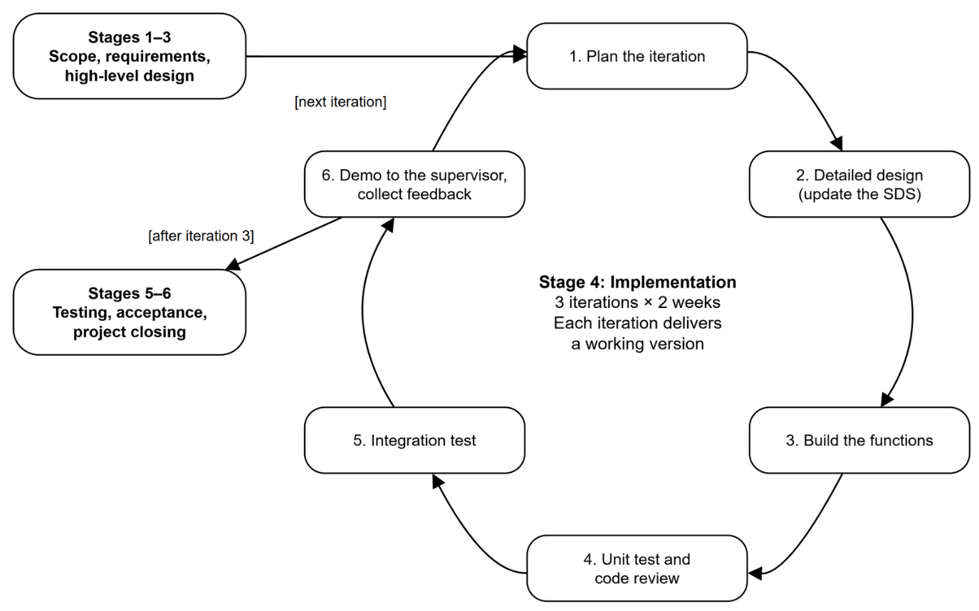
Figure 1: Iterative and incremental process inside the six SEP490 stages
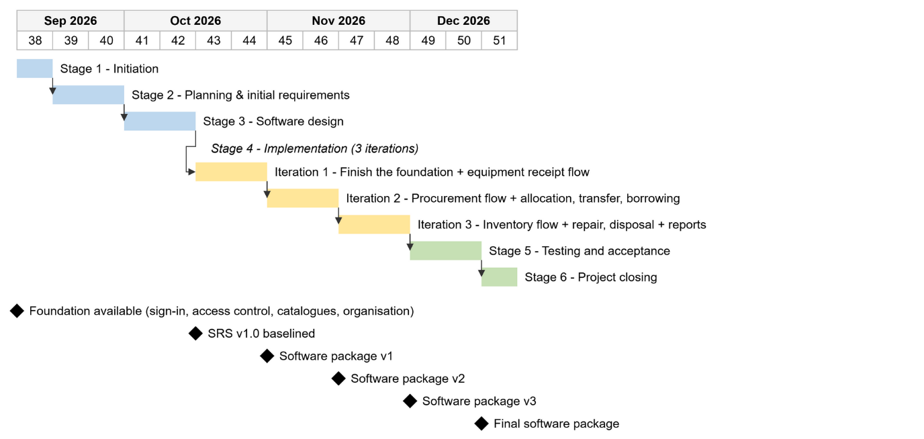
Figure 2: Project schedule: stages, iterations and milestones (week numbers in 2026)
Every iteration follows the same cycle. Work is split into small tasks of no more than two person-days each, and tracked on the team's task board. A task is done only when the code has been reviewed and merged into the shared branch, it has tests, and the SRS/SDS has been updated.
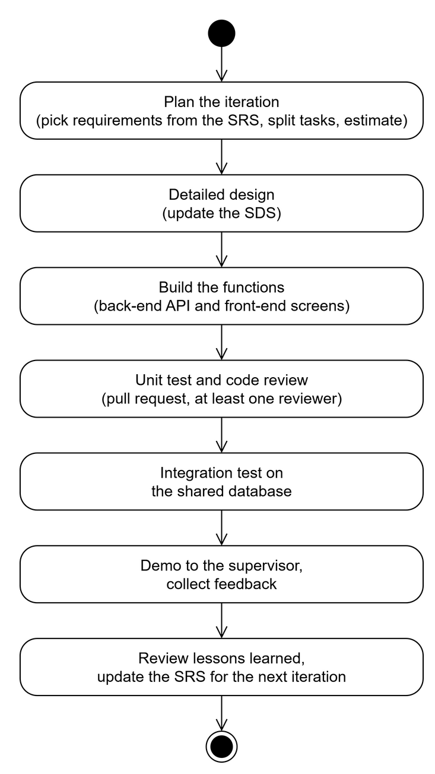
Figure 3: Activities in one iteration

2. Quality Management
The team builds quality in during the work and does not wait until the end to check:
• Defect prevention – the whole team follows one coding convention and one architecture document (layering, permission code naming, API conventions). Before each commit, tsc, ESLint and an architecture check script verify these conventions automatically.
• Review – every document is read by another member before it is sent to the supervisor; every pull request needs one reviewer. Review comments are recorded as review defects.
• Testing – unit tests (JUnit) for services and business rules; integration tests of APIs and security rules on a real PostgreSQL database; system tests based on the use cases in the SRS; acceptance tests with the supervisor.
• Database safety – the database structure is changed only through versioned Liquibase migrations. If the code and the database do not match, the application does not start.
• Metrics tracking – every week, the number of defects, the effort and the timeliness are recorded in the Project Tracking sheet and compared with the targets in Section I.5.

3. Project Training Plan
Training Area | Participants | When, Duration
Java Spring Boot 4, Spring Data JPA, Spring Security (JWT) | Whole team | Weeks 1-2, 3 sessions × 2 hours (led by M1)
Git, GitHub workflow, pull requests and code review | Whole team | Week 1, 1 session × 2 hours (led by M1)
React 19, TypeScript, Refine, Tailwind/shadcn UI | Whole team | Weeks 2-3, 3 sessions × 2 hours (led by M1)
PostgreSQL and Liquibase migrations | Whole team | Week 2, 1 session × 2 hours (led by M1)
Business domain: school facilities and equipment, MOET Circular 39/2021, asset codes, the equipment life-cycle operations, focusing on the three focus flows (procurement needs and planning, equipment receipt and asset registration, inventory) | Whole team | Weeks 1-2, 2 sessions × 2 hours (led by M1) + one session before each iteration
Row-level access control (data scopes, policies) | Whole team | Week 4, 2 sessions × 2 hours (led by M1)

4. Responsibility Assignments
The team has one leader and four members. The team leader, Luu Van Dong, knows both the business domain and the technology of the project best, and therefore takes three roles:
• Project leader – plans the work, tracks progress and manages risks; is the contact point with the supervisor.
• Business analyst (BA) – analyses the tender documents and MOET regulations; owns the SRS; defines the business flows and rules, raises open questions at meetings with the supervisor; answers the members' business questions.
• Technical leader (Tech Lead) – owns the architecture, the security mechanism and data access control, and the coding conventions; reviews pull requests and guides the team on technology.
Each member owns one whole functional area, from the database, APIs and screens to tests and the related documents; the team leader reviews everything. Each member is also the backup for another area.
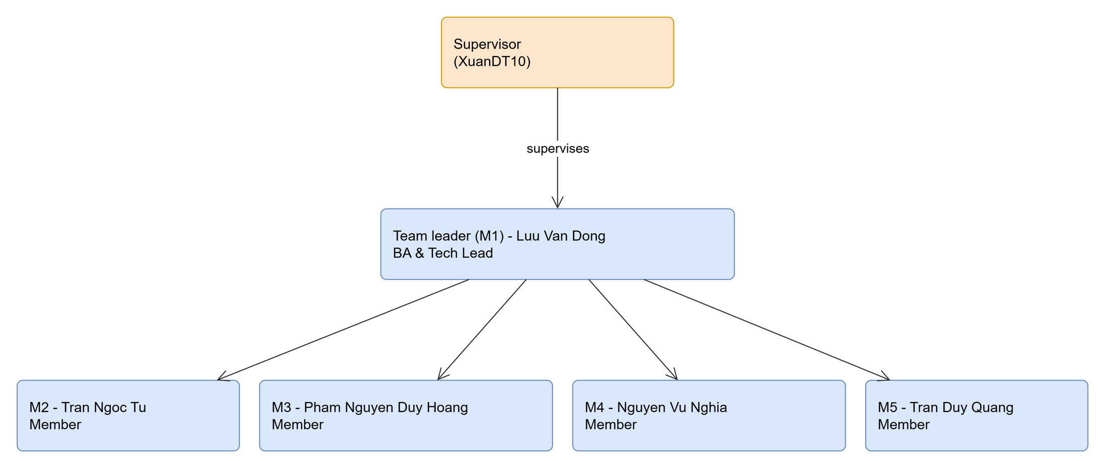
Figure 4: Project organisation chart
RACI Chart: R~Responsible, A~Accountable, C~Consulted, I~Informed
Work Package | DongLV | TuTN | HoangPND | NghiaNV | QuangTD
Report 1 – Project Introduction | A/R | R | R | C | C
Report 2 – Project Management Plan | A/R | C | C | C | R
Report 3 – SRS | A/R | C | C | C | C
Report 4 – SDS | A/R | R | R | R | C
Report 5 – Test Documentation | A | C | C | C | R
Report 6 – User Guides | A | R | R | R | R
Accounts, roles, permissions, data scopes, activity log (HT) | A/R | I | C | C | C
Shared catalogues (DM) | A | R | I | C | C
Organisation, staff and facilities (TC, CS) | A | C | R | I | C
Equipment records, asset codes; equipment receipt and asset registration flow (TS, PN) | A | I | C | R | C
Inventory flow (KK) | A | R | C | C | I
Procurement needs and planning flow (NC) | A | C | R | I | C
Allocation, transfer, borrowing and return (CP, DC, MT) | A | I | C | R | C
Fault reports, repair, maintenance (BH) | A | I | R | C | C
Disposal and write-off (TL) | A | C | I | R | C
Reports, statistics and dashboards (BC) | A | C | C | C | R
UI framework, notifications | A | C | C | C | R
System test and acceptance test | A | R | R | R | R
Report 7 and presentation | A/R | R | R | R | R

5. Project Communications
Communication Item | Who/ Target | Purpose | When, Frequency | Type, Tool, Method(s)
Daily Meeting | Whole team | Each member reports what was done, what is next and what is blocking | Daily, 15 minutes, 21:00 | Online
Weekly Meeting | Whole team | Compare progress with the plan, assign tasks, update risks | Weekly, Sunday, 1 hour | Online
Meeting with the supervisor | Team leader and whole team, supervisor | Demo results, confirm requirements, get feedback | Weekly, on the supervisor's schedule | In person or online
Weekly report | Supervisor | Report status, effort used and issues | Weekly, Friday | Online
Iteration review and demo | Whole team, supervisor | Demo the software version; the supervisor accepts or rejects the use cases of the flows built in the iteration | End of each iteration (weeks 7, 9, 11) | In person
Ad hoc discussion | Members concerned | Solve technical problems quickly | When needed | Online

6. Configuration Management

6.1 Document Management
• All documents are kept in one shared Google Drive folder, with one sub-folder per report. Nobody edits the template files directly.
• File name: SEP490_G123_Report-<n>_<Name>_v<major.minor>.docx. Each reviewed change increases the minor number; when the supervisor accepts a milestone version, the major number increases.
• Every change is recorded in the document's Change Log table (date, A/M/D, person in charge, description).
• Each accepted milestone version is exported to PDF and saved in the docs/ folder of the repository, so that the documents and the source code of the same release stay together.

6.2 Source Code Management
• One Git repository on GitHub holds the back-end (backend/), the front-end (frontend/) and the documents (docs/).
• Branches: main holds released versions only; dev is the integration branch; each task is done on its own branch feature/<area>-<short-name>, which is deleted after merging.
• A feature branch is merged into dev through a pull request. The pull request needs at least one reviewer and a passing build (type check, lint, architecture check, back-end tests).
• Each software version is tagged on main (v1.0, v2.0, v3.0, v1.0-final). Commit messages follow Conventional Commits (feat:, fix:, docs: …).
• The database structure is kept with the source code as Liquibase changelogs. Nobody edits the shared database by hand.

6.3 Tools & Infrastructures
Category | Tools / Infrastructure
Technology | React 19 + Refine 5 + TypeScript + Vite + Tailwind CSS/shadcn UI (front-end); Java 25 + Spring Boot 4 (back-end); STOMP over WebSocket for notifications
Database | PostgreSQL 16, Liquibase (schema and seed data)
IDEs/Editors | IntelliJ IDEA, Visual Studio Code, Claude, Codex
Diagramming | draw.io, PlantUML
Documentation | MS Office, Google Docs/Sheets
Version Control | GitHub (source code), Google Drive (documents)
Deployment server | Docker on the team's VPS (development and test environments); each member runs PostgreSQL on their own machine
Project management | GitHub Projects (tasks, defects, issues), Project Tracking sheet (effort, progress)

